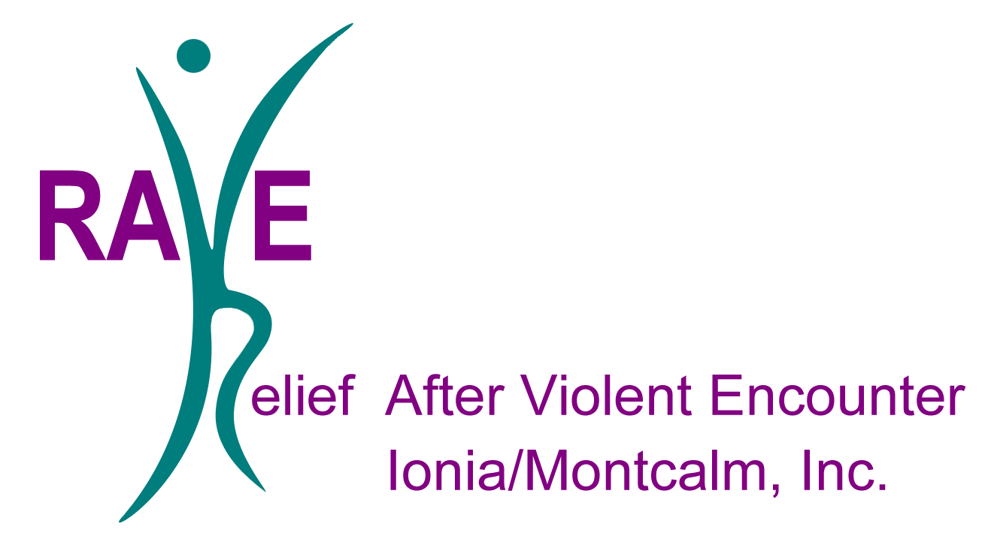
Volunteer Coordinator: Claire Hopkins
p: 616-225-1995 e: claireh@raveim.org

DIRECT SERVICE OPPORTUNITIES: (providing services that directly involve clients)
Long-term, direct service opportunities can require up to 40 hours of training. Depending on the level of interaction with clients will determine the length of training required. Most direct service opportunities will range around 4-5 hours of training. Are you able to commit to this? Yes No
Childcare – This individual will provide childcare to children while their parent is participating in services such as individual counseling, case management and support groups. Support groups are held weekly on Tuesday’s, Wednesday’s and Thursday’s. Please select the day(s) and time(s) you are able to commit to. This commitment level is long term.
Tuesday’s 3-4pm Wednesday’s 3-4pm Thursday’s 11a-12p

Shelter Group Activity – This individual would coordinate and facilitate an activity for the residents to participate in. This opportunity could be offered to adults, children or both. This opportunity is flexible and could look different depending on the volunteer’s interest/skill. Activities could include arts and crafts, sports, story time, games, group exercise, baking, stress relief/management activities, etc. This commitment level could range from short term to long term. Please list any ideas/suggestions you may have for this:
Domestic Assault Response Advocate (DARA) – This volunteer will provide crisis response to domestic and sexual assault victims immediately following an assault. A DARA volunteer would respond to a secure crime scene, hospital or the local police department. This commitment level is long term. Please contact our DARA Coordinator – Cindy Livingston.
Email: cindyl@raveim.org | Phone: 616-527-3351 ext. 225
On-Going Opportunities
Residential Service Advocate – Assist women and children in our residential facility by providing emotional support and advocacy, responding to needs. This individual would also answer the crisis line in the shelter. This commitment level is long term.
Meal Assistance – This individual will assist with menu planning and meal prep for the shelter. RAVE receives many food donations such as canned and boxed goods. Ideally, this individual would utilize the items RAVE currently has and assist women with meal planning around these items. This volunteer would create recipes and prepare meals with them women. This volunteer is welcomed to eat their prepared meals with the women and children.
Life Skills Coach – This person could also provide the women and children some needed life skill information such as budgeting, nutrition, health, taxes, house-keeping, mindfulness, childbearing etc. Please list any ideas/suggestions you may have for this: ___
Transportation Advocate – This volunteer would provide transportation to clients who may not have their own form of transportation or be able to afford public transportation. This individual would provide transportation for clients to appointments, housing/apartment tours, job interviews, court hearings, etc. within the Ionia and Montcalm counties. This commitment level could range from short to long term.
Internships and Field Experiences – Internships and field experiences are available for both undergraduate and graduate degrees. Depending on the interest and needs of the person and RAVE-I/M, Inc. would determine the placement and focus of their experience. This commitment level would be long term.

INDIRECT SERVICE OPPORTUNITIES: (providing services that do not direct client care)
Donation Coordinator – This individual would care for our donation room. This individual would assist with putting together welcome and exit bags for our residents as well as set up and run our Professional Boutique created for residents preparing for interviews. This individual may organize, pickup/drop off donations and track inventory.
Skilled Labor Volunteer – RAVE-I/M, Inc. is always in need of people who have a skilled trade. From roofing to remodeling bathrooms, whatever it is chances are we could use the help. This commitment level can vary depending on the task, but generally it is short term.
Home Preservation Inside/Outside – This individual may have a passion for cleanliness, lawn care and upkeep, gardening, and house organization. This commitment level could range from short to long term.
Community Collaboration – This opportunity may vary between business’ and services provided. Many of our women are not familiar with what services are available in the Ionia/Montcalm County. This could look like coming in to give a presentation on your services such as, day care, counseling, mindfulness, budgeting, shopping, etc. This could also look like an opportunity for a business to donate to RAVE from decorative/housing items to volunteering your services in our shelter – i.e. providing hair care, manicures/pedicures, yoga, family photos etc. Please list your business/company name and how you would like to serve RAVE:

