Relief After Violent Encounter – Ionia/Montcalm, Inc. (RAVE-I/M, Inc.)

ADULT PROGRAM DONATION NEEDS

Survivors of domestic and sexual violence often flee abuse with nothing more than the clothes on their backs. Traumatized and fearful, they turn to us for refuge from the relentless abuse they faced at the hands of their partner. Our shelter provides survivors with everything they need to start over from bedding and towels to toothbrushes and shampoo. And all of it is for free! And that’s why RAVE needs your help by donating items on our wish list. Below is a list
Paper Products
Toilet Paper
Paper Towel
Kleenex
Copy/Printer Paper
Cleaning Supplies
Disinfectant Multipurpose Cleaner
Bleach
Dishwasher Soap
Disinfectant Spray (i.e., Lysol)
Liquid Hand Soap
Laundry Detergent / Fabric Softener
Hand Sanitizer
Bleach Wipes
Hygiene Products
Shampoo and Conditioner
Toothpaste
Body Wash
Deodorant
Health Care and First Aid
Adult and Child Over the counter medications (new & sealed)
Band-Aids
Nail Clippers
Peroxide
Household Items
Pillows
Flashlights
Batteries (9V, D, C, AA)
“Ziploc” sealable containers, all sizes
Freezer Bags
Dish Towels/Cloths
Towels/washcloths
Trash Bags (13 and 30 gal.)
New Clothing
Socks (women and children)
Underwear (women and children)
Pajamas (women and children)
Slippers
Food Items
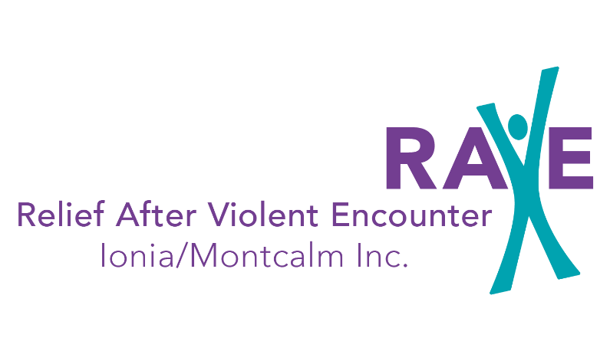
Coffee
Macaroni, Spaghetti Sauces
Canned potatoes
Canned fruit
“Hamburger Helper”
Tuna Fish
Pudding/Jell-O
Box Cereal
Meat (roasts, hamburger, pork chops, Chicken)
Canned Soups
Applesauce
Sugar
Juice/Kool-Aid
Baby Items
Diapers (all sizes, esp. 3 & 4)
Baby Wipes
Nasal Exasperators
Thermometers
Miscellaneous
Journals
Small Notebooks/Day Planners
Scotch Tape
Permanent Black Markers
Dial-A-Ride Tokens
Gas Cards

